SAFETY DATA SHEET

- CHEMICAL PRODUCT AND COMPANY IDENTIFICATION

Product Name: ES 4006-S Validation Date: 6/24/15

Company Identification: Contact Information:
US Headquarters 1-800-255-3924 (For Emergencies – CHEMTEL)
APTech Group, Inc. 1-866-489-9831 (For product information)
11411 Williamson Road 1-513-761-6856 (Fax)
Cincinnati, Ohio 45241 USA info@aptechsolids.com (email)
- HAZARDS IDENTIFICATION

Classification of the substance or mixture
Corrosive to metals (Category 1), H290
Skin corrosion (Category 1A), H314
Serious eye damage (Category 1), H318
Acute toxicity, Oral (Category 5), H303
Reproductive toxicity (Category 1B), H360

PICTOGRAM/SYMBOL:
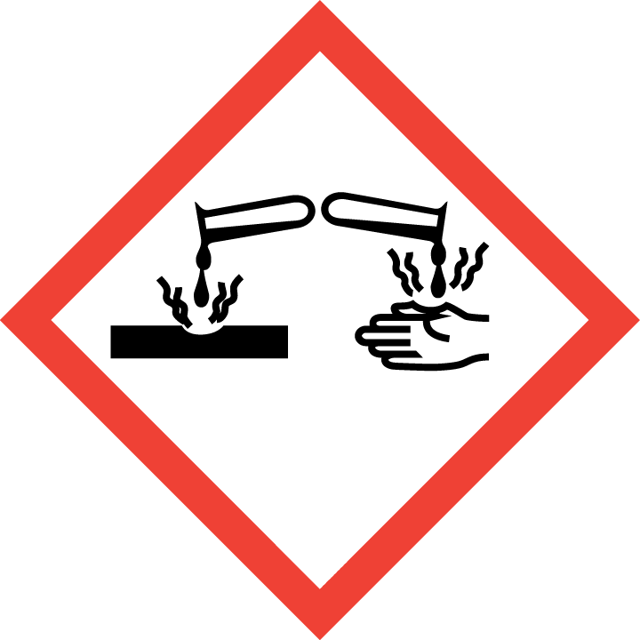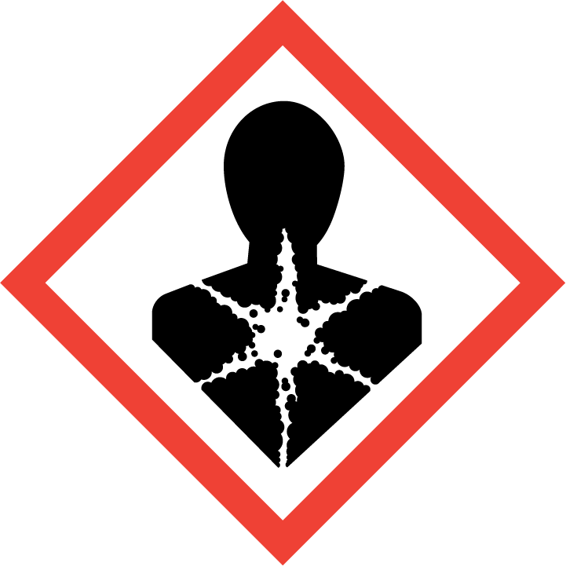

SIGNAL WORD: DANGER

HAZARD STATEMENTS - LABEL ELEMENTS
Health Hazards Statement(s)
H303 |  | May be harmful if swallowed
H314 |  | Causes severe skin burns and eye damage
H318 |  | Causes serious eye damage
H360 |  | May damage fertility or the unborn child
Physical Hazards Statement(s)
H290 | May be corrosive to metals
Precautionary Statement(s) - Prevention
P201 | Obtain special instructions before use.
P202 | Do not handle until all safety precautions have been read and understood.
P234 | Keep only in original container.
P260 | Do not breathe dust, fume, gas, mist, vapors, spray
P264 | Wash skin and contaminated clothing thoroughly after handling
P280 | Wear protective gloves, protective clothing, eye protection, face protection
Precautionary Statement(s) – Response
P301+P330+P331 | IF SWALLOWED: Rinse mouth. Do NOT induce vomiting.
P303+P361+P353 | IF ON SKIN (or hair): Remove/Take off immediately all contaminated clothing. Rinse skin with water/shower.
P363 | Wash contaminated clothing before reuse.
P304+P340 | IF INHALED: Remove victim to fresh air and keep at rest in a position comfortable for breathing.
P305+P351+P338 | IF IN EYES: Rinse cautiously with water for several minutes. Remove contact lenses, if present and easy to do. Continue rinsing.
P310 | Immediately call a POISON CENTER or doctor/physician
P308+P313 | IF exposed or concerned: Get medical advice/attention
P390 | Absorb spillage to prevent material damage.
Precautionary Statement(s) – Storage
P405 | Store locked up.
P406 | Store in corrosive resistant container with a resistant inner liner.
Precautionary Statement(s) - Disposal
P501 | Dispose of contents/container in accordance with applicable local, regional, national, and/or international regulations
- COMPOSITION / INFORMATION ON INGREDIENTS

INGREDIENT(S) | CAS Number | Weight %
Sodium Hydroxide | 1310-73-2 | 1-5
Sodium Carbonate | 497-19-8 | 40-45
Trisodium Phosphate | 7601-54-9 | 15-20
Sodium Tetraborate | 1303-96-4 | 15-20

>20% of mixture consists of ingredients of unknown toxicity. Exact percentages are withheld as trade secrets.

- FIRST AID MEASURES

EYE CONTACT: Get medical attention immediately. Immediately flush eyes with plenty of water, occasionally lifting the upper and lower eyelids. After 5 minutes, check for and remove any contact lenses. Continue to rinse for at least 15 minutes.
SKIN CONTACT: Get medical attention immediately. Wash with plenty of water. Remove contaminated clothing and shoes. Continue to rinse for at least 15 minutes. Wash clothing before reuse. Clean shoes thoroughly before reuse. Destroy contaminated shoes.
INHALATION: Get medical aid immediately. Remove from exposure and move to fresh air immediately and keep in position comfortable for breathing. If breathing is difficult, give oxygen. Do NOT use mouth-to-mouth resuscitation. If breathing has ceased apply artificial respiration using oxygen and a suitable mechanical device such as a bag and a mask.
INGESTION: Get medical attention immediately. Do NOT induce vomiting. If victim is conscious and alert, wash out mouth with water then give water. Never give anything by mouth to an unconscious person. If vomiting occurs spontaneously, keep airway clear.
NOTES TO PHYSICIAN: The absence of visible signs or symptoms of burns does NOT reliably exclude the presence of actual tissue damage may contraindicate the usage of gastric lavage.
- FIRE FIGHTING MEASURES

NOTE: Solid product. Product will melt and combustion may occur when exposed to fire.
General information: As in any fire, wear a self-contained breathing apparatus in pressure-demand, MSHA/NIOSH (approved or equivalent), and full protective gear. During a fire, irritating and highly toxic gases may be generated by thermal decomposition or combustion. Use water spray to keep fire-exposed containers cool.
Extinguishing Media: Use agents appropriate for surrounding fire. Do NOT use straight streams of water.
- ACCIDENTAL RELEASE MEASURES

IN CASE OF SPILL OR OTHER RELEASE: Remove sources of ignition. Ventilate area. Use appropriate personal protective equipment as indicated in Section 8 of the SDS when risk assessment indicates this is necessary. Use non-sparking tools and equipment. Sweep or shovel spilled materials into suitable containers. Dispose of in accordance with all local, state and federal requirements. Do not allow product or residues to enter waterway or any source of drinking water.

- HANDLING AND STORAGE

HANDLING: Use appropriate personal protective equipment (see Section 8). Eating, drinking and smoking should be prohibited in areas where this material is handled, stored and processed. Workers should wash hands and face before eating, drinking and smoking. Do not get in eyes or on skin or clothing. Do not breathe vapor or mist. Do not ingest. Use only with adequate ventilation. Keep in the original container. Store and use away from heat, sparks, open flame or any other ignition source. Do not reuse container.
STORAGE: Store in accordance with local regulations. Store in a segregated and approved area. Store in original container protected from direct sunlight in a dry, cool and well-ventilated area, away from incompatible materials (see Section 10) and food and drink. Separate from oxidizing materials and acids. Keep container tightly closed and sealed until ready for use.

- EXPOSURE CONTROLS / PERSONAL PROTECTION

ENGINEERING CONTROLS: Facilities storing or utilizing this material should be equipped with an eyewash facility and a safety shower (ANSI Z358.1). Use adequate general or local explosion-proof ventilation.

COMPONENT | CAS NUMBER | ACGIH TWA | ACGIH STEL | ACGIH CEILING | OSHA FINAL PEL TWA | IDLH
Sodium Hydroxide | 1310-73-2 | - | - | 2 mg/m3 | 2 mg/m3 | 10 mg/m3
Sodium Tetraborate | 1303-96-4 | 2 mg/m3 | - | - | 10 mg/m3 | -

PERSONAL PROTECTIVE EQUIPMENT
Eyes: Wear chemical splash goggles that meet the requirements of 29 CFR 1910.133 or European Standard EN 166.
Skin: Wear appropriate protective gloves to prevent skin exposure (29 CFR 1910.138 or EN 374).
Clothing: Wear appropriate protective clothing to prevent skin exposure.
Respirators: A respiratory protection program that meets OSHA 29 CFR 1910.134 and ANSI Z88.2 requirements or European Standard EN 149 must be followed whenever workplace conditions warrant respirator use.

- PHYSICAL AND CHEMICAL PROPERTIES

FORM: | Solid
ODOR: | Slight
ODOR THRESHOLD: | No data available
COLOR: | White
pH: | ~11.5 @ 4%
FREEZING POINT: | No data available
BOILING POINT: | No data available
FLASH POINT: | No data available
EVAPORATION RATE: | No data available
FLAMMABILITY: | No data available
FLAMMABILITY/EXPLOSIVE LIMIT: | No data available
AUTOIGNITION TEMPERATURE: | No data available
VAPOR PRESSURE: | No data available
VAPOR DENSITY: | No data available
DENSITY: | No data available
SOLUBILITY IN WATER: | Complete over time in water
PARTITION COEFFICIENT N-OCTANOL/WATER: | No data available
AUTOIGNITION TEMPERATURE: | No data available
DECOMPOSTION TEMPERATURE: | No data available

10. STABILITY AND REACTIVITY

STABILITY: The product is stable.
INCOMPATIBILITY WITH VARIOUS SUBSTANCES: Reactive or incompatible with the following materials: oxidizing materials, acids, aluminum, copper, brass, bronze, tin.
HAZARDOUS POLYMERIZATION: Under normal conditions of storage and use, hazardous polymerization will not occur.
HAZARDOUS DECOMPOSITION PRODUCTS: Decomposition products may include the following materials: carbon monoxide, sodium oxide, phosphorus oxides.
11. TOXICOLOGICAL INFORMATION

TOXICITY: No data available for product
CARCINOGENICITY
Product/Ingredient Name | ACGIH | IARC | NTP
- | - | - | -

12. ECOLOGICAL INFORMATION

ENVIRONMENTAL INFORMATION: No Data Available For Product.
13. DISPOSAL CONSIDERATIONS

Chemical waste generators must determine whether a discarded chemical is classified as a hazardous waste. U.S. EPA guidelines for the classifications are listed in 40CFR 261.3. Additionally, waste generators must consult state and local hazardous waste regulations to ensure complete and accurate classification.

14. TRANSPORTATION INFORMATION

U.S. Bill of Lading Description: UN 3262, corrosive solid, basic, inorganic, n.o.s. (Sodium Hydroxide) 8, II

15. REGULATORY INFORMATION

INTERNATIONAL INVENTORIES
All components of this product are listed on the following inventories: U.S.A. (TSCA), Canada (DSL).

U.S. REGULATIONS
CALIFORNIA PROPOSITION 65: This product contains a chemical(s) known to the state of California to cause birth defects or other reproductive harm (None).

STATE RIGHT TO KNOW (RTK)
INGREDIENT(S) | CAS# | MA | NJ | PA | MN
Sodium Hydroxide | 1310-73-2 | X | X | X | -
Sodium Tetraborate | 1303-96-4 | X | X | X | X
Trisodium Phosphate | 7601-54-9 | X | X | X | -

CERCLA/SARA 302/304
INGREDIENT(S) | CAS# | Weight % | CERCLA/SARA RQ (lbs) | Section 302 TPQ (lbs)
Sodium Hydroxide | 1310-73-2 | 1-5 | 1000 | -
Trisodium Phosphate | 7601-54-9 | 15-20 | 5000

SARA 311/312 Hazard Categories
Immediate: X
Delayed: -
Fire: -
Reactivity: -
Sudden Release of Pressure: -
SARA 313:
None
Clean Air Act:
Not regulated.
Clean Water Act:
Not regulated.

16. OTHER INFORMATION

Hazardous Material
Information System (U.S.A.) Health: 3 Flammability: 0 Reactivity: 0

National Fire Protection
Association (U.S.A.) Health: 3 Flammability: 0 Reactivity: 0

HMIS and NFPA use a numbering scale ranging from 0 to 4 to indicate the degree of hazard. A value of 0 means that the substance possesses essentially no hazard; a rating of 4 indicates high hazard.
Date of Creation: 02/02
Issue Number: 5.4
Date of Revision: 6/24/2015
Prepared By: Compliance Group
The information contained in this Safety Data Sheet is intended to comply with the requirements of 29CFR 1910.1200. This information is believed to be accurate and based on data available to the manufacturer at this time. It is intended to be used as a guide to the safe handling and use by properly trained individuals. It is the end users responsibility to determine the suitability of the information for their particular purposes. This information is provided without warranty.

